Republican would represent Ulster, Sullivan
By Nathan Brown Times Herald-Record

Published: 2:00 AM - 03/07/12
Last updated: 6:02 AM - 03/07/12
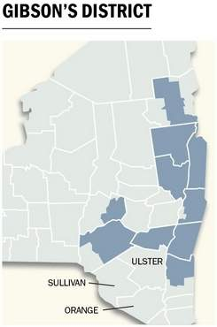
If the latest redistricting proposal stands, Ulster and Sullivan counties would be in the district of Chris Gibson, a Columbia County Republican whose district already includes much of the Hudson Valley and Catskills.

Since he was elected in November 2010, Gibson has been a generally conservative voice and vote, but has sought compromise on a couple major fiscal bills.

Gibson, 47, grew up in Kinderhook, where he still lives with his wife and three children. He spent more than two decades in the U.S. Army, with deployments abroad including Iraq, Haiti and Kosovo, before retiring as a colonel in early 2010.

Gibson voted in favor of Wisconsin Republican Rep. Paul Ryan's budget proposal, and generally supports cutting taxes and spending. However, he has disagreed with the GOP leadership on a few major measures — he was one of only three House Republicans to vote in favor of a Democrat-supported payroll tax cut extension in December, and he has worked for compromise on some of the spending cuts proposed by the leadership.

Gibson has shown a strong interest in agricultural, military and energy issues, and serves on the House Armed Services and Agriculture committees.

He says he supports an "all-of-the-above" energy policy, including more drilling and nuclear power but also more green technology. He says he supports restructuring the military to one more appropriate for "a republic, not an empire," and has introduced legislation to limit the president's power to go to war without congressional authorization.

